Project Prototypes

Your first step is to create a prototype of the project so you can work out the project details. This prototype should include a document with the following items:

1. ***Introduction*** – Purpose, User Profile and workflows. Here you should describe the overall project and indicate who is using the system and how they will interact with the system.
2. ***Requirements*** – Functional and non-functional requirements. This is a restatement of the requirements with analysis of items you are committing to and clarification items as needed.
3. ***User Stories from the requirements –*** The requirements (above) asks you to think through the provided requirements and rephrase them in your own works. During this step you will create a set of user stores (at least 5 based on the requirements provided).

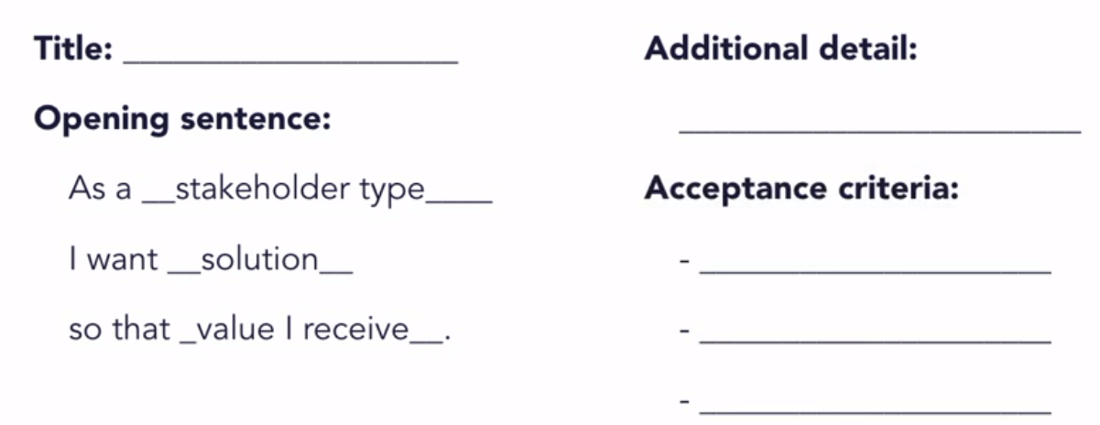

1. ***GUI Prototype*** – Drawing a UI pictures and descriptions. You will need to draw at least 3 images that describe how the user will interact with the application.

Prototype Rubric

|  |  |  |
| --- | --- | --- |
| **What** | **Details** | **Points** |
| introduction | Clearly describes the purpose, the users and how they will interact with the system. | 10 |
| Requirements | Clear restatement of requirements in the group’s own words. | 20 |
| User Stories | Clear user stories in the formatted provided in course. In particular, the acceptance criteria are testable, atomic, and implementation free. | 35 |
| Prototypes | Prototype pictures are clear, well thought out and provide clear value in clarifying what the UI will look like. There should be little omissions or non-clear areas. | 45 |
| Total |  | 100 |